Lab 5

IT24100568

LUKE L.S.

1.

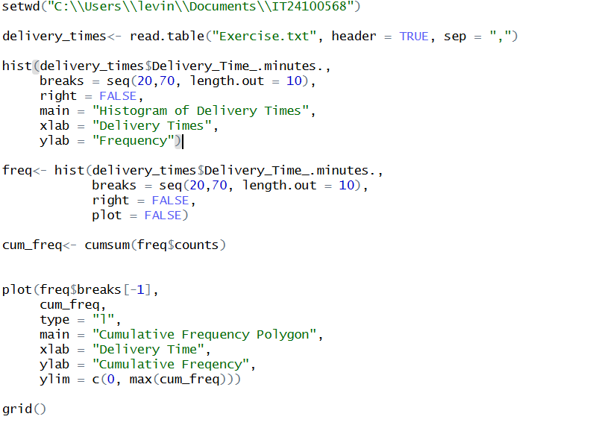

3.

The distribution of delivery times is **roughly symmetric**, centered around **40 minutes**. Frequencies rise towards the middle (30–45 minutes), then fall off towards the ends (20–25 minutes and 65–70 minutes). There is **no extreme skewness** and the highest frequency (the “peak”) is around the **35–45 minute** interval.

4.

